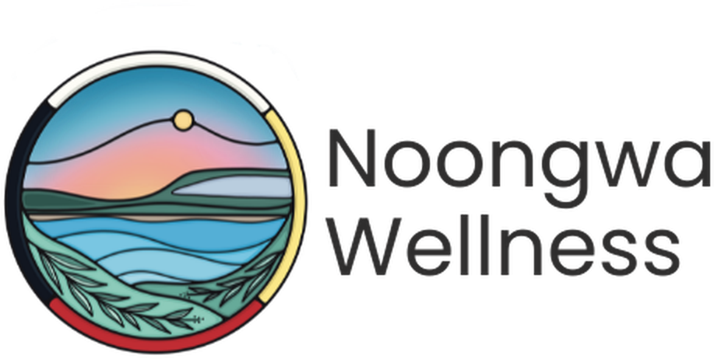

Primary Care Nurse Practitioner
FULL-TIME · NEYAASHIINIGMIING, ONTARIO

Neyaashiinigmiing is the community of the Chippewas of Nawash Unceded First Nations, located on the beautiful shores of Georgian Bay. It is a place where the water, the land, and the community shape how care is delivered and where Noongwa Wellness is building something new: a primary care clinic rooted in Anishinaabe values, culture, and self-determination.
We are looking for a full-time Primary Care Nurse Practitioner to join our small, close-knit clinical team as a founding member and primary care provider. You will work in true partnership with our physician, help build a care model from the ground up, and practice the way autonomous primary care is meant to feel: full-scope, relational, and grounded in community.

At a Glance
Position | Nurse Practitioner (NP); Primary Care
Employment Type | Full-time
Hours | 35 hours/week, Monday to Friday, occasional evenings or weekends to support community outreach events
Location | Neyaashiinigmiing, Ontario
Compensation | $142,700 to $155,673
Additional Compensation | Enhanced paid time off, including dedicated cultural days, paid time off between Christmas and New Year's; pay in lieu of a formal benefits and pension package while Noongwa builds toward enrolment in both, targeted for 2027
Reports To | Pernell Jones, Executive Director
Application Deadline | Open until filled
To Apply | Send a resume and short cover letter to admin@noongwa.ca

Why This Role Is Different
Autonomous Full-Scope Practice  Diagnose, prescribe and work at the very top of your NP scope to co-manage a shared roster. | A Founding Team Member  Help shape the clinical model, workflows, and culture of a brand-new primary care clinic.
True Work-Life Balance  Monday to Friday, daytime hours. Enhanced time off. | Collaborative Physician Partnership  Work alongside our physician as a true clinical partner.
Rooted in Culture  Care is guided by the IPHCC Model of Wholistic Health and Wellbeing and Grandfather Teachings. | Home on the Bay  Live and work on the shores of Georgian Bay, in a community that welcomes you in.
Noongwa Wellness is more than a clinic. It is a space shaped by the land and by Anishinaabe values, where health and belonging come together. As our Nurse Practitioner, you will not just be filling a role; you will be helping shape what community-led primary care looks like for generations to come.

The Opportunity
As the Nurse Practitioner at Noongwa Wellness, you will serve as a primary care provider for community members, working in true partnership with our physician and clinical team. This role combines full-scope, autonomous practice with the opportunity to help build a primary care model rooted in Anishinaabe values from the ground up.

Duties and Responsibilities

Clinical Care and Primary Care Practice
- Provide comprehensive primary care within your full NP scope of practice, including diagnosis, treatment planning, and prescribing
- Order and interpret diagnostic tests, and refer to specialists as needed
- Manage acute episodic care and chronic disease, including diabetes, hypertension, and mental health concerns
- Provide preventive care, screening, and immunizations across the lifespan
- Support in-person and home-visit care as needed

Patient Panel and Attachment
- Build and manage a patient panel, including intake, health history, and risk screening for newly attached patients
- Develop trusting, long-term relationships with patients and families
- Coordinate referrals and follow-up with specialists, hospitals, and community partners
- Maintain accurate, timely documentation in the EMR for all clinical encounters

Clinical Leadership and Clinic Development
- Help shape clinical protocols, medical directives, and workflows as a founding member of the clinical team
- Collaborate closely with the physician on shared care planning and complex case management
- Contribute to policy development, quality improvement, and accreditation readiness as the clinic grows
- Support clinical supervision and mentorship of nursing and allied health staff as the team expands

Cultural Safety and Community Connection
- Provide care that embraces both Indigenous and Western worldviews and the IPHCC Model of Wholistic Health and Wellbeing
- Respect the formal and informal protocols of the Chippewas of Nawash Unceded First Nation
- Participate in community events and cultural practices as welcomed

Requirements
- Active registration in the Extended Class with the College of Nurses of Ontario (CNO)
- Up-to-date immunization records
- Satisfactory vulnerable sector check as a condition of employment
- Valid Ontario driver’s licence and access to a reliable vehicle, to support home visits & community outreach
- Comfort working independently and collaboratively in a small, evolving team

Skills and Abilities
- Strong clinical judgment, diagnostic reasoning, and confidence practising autonomously
- Excellent communication and relationship-building skills
- Cultural humility and a genuine commitment to community-rooted care
- Comfort with ambiguity and enthusiasm for helping build a new clinic
- Organized, self-directed, and dependable

Organizational Relationships
- Reports to the Executive Director
- Works in close clinical partnership with the physician and collaboratively with the Primary Care Nurse.
- Works closely with the Medical Administrator and Client Care Admin team
- Respects the formal and informal protocols of the Chippewas of Nawash Unceded First Nation community

Work Environment
- Based at the Noongwa Wellness clinic in Neyaashiinigmiing
- Some travel within the community to support home visits & community outreach
- Occasional exposure to smoke from traditional practices (e.g., tobacco, sage, sweetgrass, cedar)

How to Apply
We strongly encourage applications from Indigenous and non-Indigenous candidates who share a commitment to culturally safe, community-rooted care.
This posting is for a new position. Noongwa Wellness does not use AI to screen, assess or select applicants.
Please submit a resume and short cover letter to admin@noongwa.ca.
Chi-Miigwech. Thank you for your interest in joining Noongwa Wellness.

