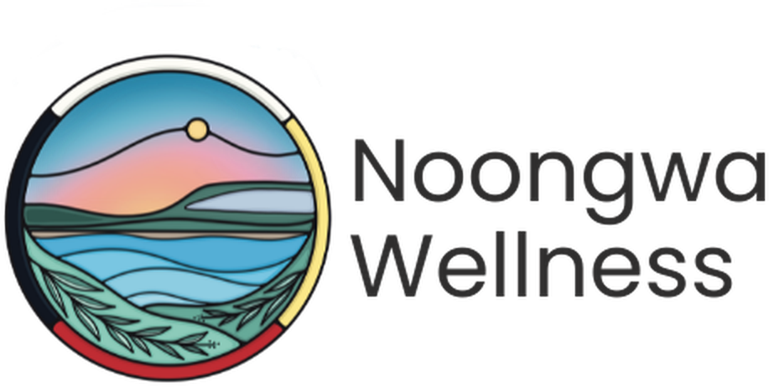

Primary Care Nurse
  - Registered Nurse (RN) or
  - Registered Practical Nurse (RPN)
FULL-TIME · NEYAASHIINIGMIING, ONTARIO

Neyaashiinigmiing is the community of the Chippewas of Nawash Unceded First Nations, located on the beautiful shores of Georgian Bay. It is a place where the water, the land, and the community shape how care is delivered and where Noongwa Wellness is building something new: a primary care clinic rooted in Anishinaabe values, culture, and self-determination.
We are looking for a full-time Nurse to join our small, close-knit clinical team as a founding member. You will work in daily partnership with our physician, help shape how care is delivered from the ground up, and practice nursing the way it is meant to feel: relational, full-scope, and grounded in community.

At a Glance
Position | Primary Care Nurse
Employment Type | Permanent Full-time
Hours | 35 hours/week, Monday to Friday; occasional weeknights or weekends for community outreach events
Location | Neyaashiinigmiing, Chippewas of Nawash Unceded First Nation, Ontario
Compensation | Registered Nurse: $96,400 - $105,164  Registered Practical Nurse: $61,800 - $67,418
Additional Compensation | Enhanced paid time off, including dedicated cultural days, pay in lieu of a formal benefits and pension package while Noongwa builds toward full benefits and pension enrolment, targeted for 2027
Reports To | Pernell Jones, Executive Director
Application Deadline | Open until filled
To Apply | Send a resume and short cover letter to admin@noongwa.ca

Why This Role Is Different
Full-Scope Practice  Work at the top of your licence: assessment, chronic disease management, home visit support, and more. | A Founding Team Member  Help shape the nursing role, clinical workflows, and team culture from the very beginning.
True Work-Life Balance  Monday to Friday, daytime hours. Enhanced time off. | Close Physician Partnership  Work in daily, direct partnership with our physician.
Rooted in Culture  Care is guided by the IPHCC Model of Wholistic Health and Wellbeing and Grandfather Teachings. | Home on the Bay  Live and work on the shores of Georgian Bay, in a community that welcomes you in.
Noongwa Wellness is more than a clinic. It is a space shaped by the land and by Anishinaabe values, where health and belonging come together. As a nurse here, you will not just be filling a role; you will be helping shape what community-led health care looks like for generations to come.

The Opportunity
As a key member of the Noongwa Wellness clinical team, the Primary Care Nurse provides direct nursing care and helps build the systems, relationships, and workflows that a growing clinic needs. This role combines hands-on clinical practice with the chance to help shape how care is delivered as the organization grows.

Duties and Responsibilities

Clinical Care and Nursing Practice
- Provide direct nursing care within your scope of practice, including assessments, immunizations, wound care, and medication administration
- Support chronic disease monitoring and ongoing care planning alongside the physician
- Support in-person and home-visit care as needed
- Respond to walk-in and urgent care needs at the clinic

Patient Onboarding and Attachment
- Support the onboarding of new patients, including intake, health history, and risk screening
- Build trusting, long-term relationships with patients and families
- Coordinate referrals and follow-up with specialists and community partners
- Maintain accurate documentation in the EMR for all clinical encounters

Clinic Development and Team Building
- Help establish clinical workflows, nursing workspace set-up, and IPAC practices as a founding member of the clinical team
- Collaborate closely with the physician and administrative team in a small, evolving clinic
- Contribute to policy development and quality improvement as the clinic grows

Cultural Safety and Community Connection
- Provide care that reflects both Indigenous and Western worldviews and the IPHCC Model of Wholistic Health and Wellbeing
- Respect the formal and informal protocols of the Chippewas of Nawash Unceded First Nation
- Participate in community events and cultural practices as welcomed

Requirements
- Active registration in good standing with the College of Nurses of Ontario (CNO)
- Up-to-date immunization records
- Satisfactory vulnerable sector check as a condition of employment
- Valid Ontario driver’s licence & access to a reliable vehicle, to support home visits and community outreach
- Experience in Indigenous health is considered an asset
- Comfort working independently and collaboratively in a small, evolving team

Skills and Abilities
- Strong clinical judgment and adaptability
- Excellent communication and relationship-building skills
- Cultural humility and a genuine commitment to community-rooted care
- Comfort with ambiguity and enthusiasm for helping shape a new clinic
- Organized, self-directed, and dependable

Work Environment
- Occasional exposure to smoke from traditional practices (e.g., tobacco, sage, sweetgrass, cedar)
We strongly encourage applications from Indigenous and non-Indigenous candidates who share a commitment to culturally safe, community-rooted care. This is a posting for a new position. Noongwa Wellness does not use AI to screen, assess or select applicants.
Please submit a resume and short cover letter to admin@noongwa.ca.
Chi-Miigwech. Thank you for your interest in joining Noongwa Wellness.

