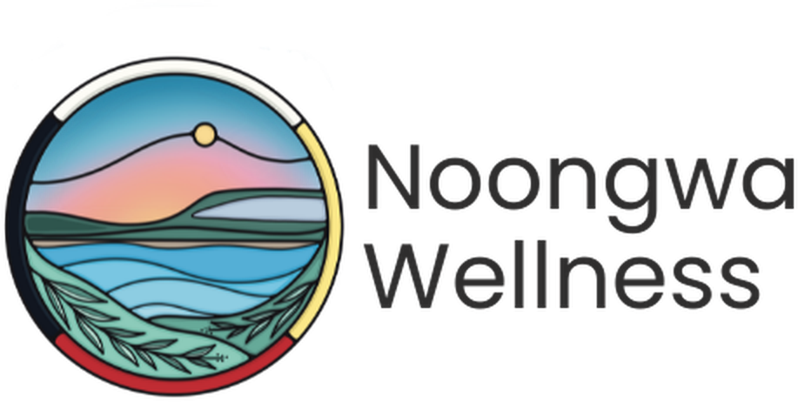

Casual Phlebotomist
  - Phlebotomist or
  - Nurse with Phlebotomy Skills
CASUAL · NEYAASHIINIGMIING, ONTARIO

Neyaashiinigmiing is the community of the Chippewas of Nawash Unceded First Nation, located on the beautiful shores of Georgian Bay. It is a place where the water, the land, and the community shape how care is delivered and where Noongwa Wellness is building something new: a primary care clinic rooted in Anishinaabe values, culture, and self-determination.
We are looking for a casual Phlebotomist to join our small, close-knit clinical team. You will provide blood collection when the clinic needs it, in a calm and welcoming way that helps community members feel at ease. Phlebotomists and nurses with phlebotomy skills are encouraged to apply.

At a Glance
Position | Casual Phlebotomist
Employment Type | Casual (part-time, as needed)
Hours | Shifts are booked in advance around clinic bloodwork days. There is no minimum number of hours, so you can fit this work around your other commitments.
Location | Neyaashiinigmiing, Chippewas of Nawash Unceded First Nation, Ontario
Compensation | $23.50 to $29.50 per hour
Reports To | Pernell Jones, Executive Director
Application Deadline | Open until filled
To Apply | Send a resume and short cover letter to admin@noongwa.ca

Why This Role Is Different
Flexible, Casual Shifts  Choose the shifts that work for you. We book ahead around clinic bloodwork days. | Be Part of Something New  Help a growing primary care clinic run well from its earliest days.
Care That Stays Close to Home  Gentle, skilled blood collection helps keep care close to home for community members. | A Small, Welcoming Team  Work alongside our nurse, physician, and administrative assistant.
Rooted in Culture  Care is guided by the IPHCC Model of Wholistic Health and Wellbeing and Grandfather Teachings. | Home on the Bay  Live and work on the shores of Georgian Bay, in a community that welcomes you in.
Noongwa Wellness is more than a clinic. It is a space shaped by the land and by Anishinaabe values, where health and belonging come together. As a phlebotomist here, you will not just be drawing blood; you will be helping make community-led health care feel safe, calm, and close to home.

The Opportunity
As a casual Phlebotomist at Noongwa Wellness, you will collect and prepare blood samples for Noongwa Clients and community members on bloodwork days. This role offers flexible, as-needed work in a welcoming clinic where your skill and kindness make a real difference.

Duties and Responsibilities

Blood Collection and Specimen Handling
- Collect blood samples by venipuncture and capillary methods, following clinic procedures and lab requirements
- Confirm each person’s identity and the tests requested before every collection
- Label, package, and prepare specimens for lab pick-up or transport
- Record collections accurately and report any concerns to the nurse or physician

Safety and Infection Prevention
- Follow infection prevention and control (IPAC) practices, including hand hygiene and personal protective equipment
- Handle needles, sharps, and biohazard materials safely
- Keep the collection area clean, stocked, and ready for use

Community Care and Cultural Safety
- Welcome community members with patience and respect, and help children, elders, and anxious clients feel at ease
- Protect the privacy of personal health information at all times
- Respect the formal and informal protocols of the Chippewas of Nawash Unceded First Nation
- Participate in community events and cultural practices as welcomed

Requirements
- Phlebotomy certificate or equivalent training
- Active registration in good standing with the College of Nurses of Ontario (CNO), for nurses applying with phlebotomy skills
- Up-to-date immunization records
- Satisfactory vulnerable sector check as a condition of employment
- Reliable transportation to and from Neyaashiinigmiing
- Experience in point-of-care testing or specimen handling is considered an asset
- Experience working with Indigenous communities is considered an asset

Skills and Abilities
- Steady hands, careful technique, and strong attention to detail
- A calm, kind manner with people of all ages
- Excellent communication skills
- Cultural humility and a genuine commitment to community-rooted care
- Organized, dependable, and comfortable working independently

Work Environment
- Based at the Noongwa Wellness clinic in Neyaashiinigmiing
- Occasional exposure to smoke from traditional practices (e.g., tobacco, sage, sweetgrass, cedar)

How to Apply
We strongly encourage applications from Indigenous and non-Indigenous candidates who share a commitment to culturally safe, community-rooted care. This posting is for a new position. Noongwa Wellness does not use AI to screen, assess or select applicants.

Please submit a resume and short cover letter to admin@noongwa.ca.
Chi-Miigwech. Thank you for your interest in joining Noongwa Wellness.

